**Cv :** zuhoor abbas salman

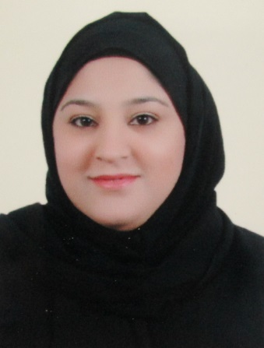

**Personal information:**

**Date of birth:** 23 / 12 / 1993 **Place of birth:** riffa

**Nationality**: Bahraini

**Address:** house / 852 road / 1112 block 1211 [hamad town]

**E-mail:** [**zuhooralshakhoori93@gmail.com**](mailto:zuhooralshakhoori93@gmail.com)

**Phone No : 39927886**

**Education or qualification / secondary certificate:**

Al-tadhamun secondary girls school

**Languages:**

Arabic: excellent

English: good

**Skills :**

-self discipline

-use of the internet and Microsoft office

**Professional skills:**

-I worked in kindergarten teacher for one year and worked as a teacher assistant for half a semester .

**Qualities:**

-fast learning

-flexiblet

-confidence

**Hobbies and interests:**

-photography and swimming

**The wanted job:**

Seles , customer service , input data , assistant service , reception .